AgriRent

A project submitted to
UKA TARSADIA UNIVERSITY
in partial fulfilment of the requirements
for the degree of

Bachelors of Science in Information Technology
for 5th Semester
2025-26
Group Number: 24

Submitted By:
Harmish Kachhadiya -202307100110120
Darshak Vaghamshi -202307100110172
Yash Gadhiya - 202307100110141

Guided By:
Dr. Preeti Bhatt
Assistant Professor


Babu Madhav Institute of Information Technology
Uka Tarsadia University
Bardoli – 394350
December 2025

CERTIFICATE

This is to certify that the project report entitled “AgriRent” has been carried out by Mr. Harmish Kachhadiya (202307100110120),
Mr. Darshak Vaghamshi (202307100110172) and Yash Gadhiya (202307100110141) under my guidance in partial fulfillment of the requirement for the Bachelors of Science in Information Technology during the academic year 2025-26.

Date: xx-xx-2025

____________________ ____________________
Dr. Preeti Bhatt Dr. Jitendra Nasriwala
Project Guide Programme Coordinator

External Examiner(s)

___________________

___________________



BABU MADHAV INSTITUTE OF
INFORMATION TECHNOLOGY
Table of Contents
Chapters | Particulars |  |  | Page no.
1 | Introduction
1 | 1.1 | Problem Definition
1 | 1.2 | Purpose
1 | 1.3 | Scope
2 | Overall Description
2 | 2.1 | Product Perspective/ Environment Description
2 |  | 2.1.1 | Hardware Interface/ Hardware Specification
2 |  | 2.1.2 | Software Interface/ Software Specification
3 | System Specific Requirements
3 | 3.1 | Functional Requirement
3 | 3.2 | Non-functional Requirement
4 | System Analysis
4 | 4.1 | Use case Diagram
4 | 4.2 | Activity Diagrams
5 | System Design
5 | 5.1 | Database Design
5 | 5.1 | 5.1.2 | Data Dictionary
6 | System Implementation
6 | 6.1 | Screenshots
7 | Testing
7 | 7.1 | Test Cases
8 | Future Enhancement
9 | Conclusion
10 | Bibliography

List of Figures and Diagrams

Figure No. | Figure Description | Page No.

Chapter 1: Introduction
  - Problem Definition
- AgriRent is a comprehensive web-based system designed to connect farmers and equipment owners within a district, enabling farmers to rent agricultural machinery and purchase essential farm products online.
- The platform facilitates easy registration and login for different user types (farmer, equipment owner, admin), offers searchable listings for equipment and products, supports booking and ordering with real-time availability checks, and integrates secure payment options through UPI.
- AgriRent includes features for reviews, complaints, admin approvals for quality control, and provides scalable, secure, and mobile-friendly access to make modern farming resources more affordable and accessible to local agricultural communities.

  - Project Purpose
- An AgriRent is web based system that lets equipment owners rent out farming machines to farmers.
- It also helps manage the sale of farming products. The goal is to make it easy and affordable for farmers to access what they need.
  - Project Scope

- A web-based platform accessible via desktop and mobile browsers.
- The platform is limited to one district and all features and services will be available only to users within that district.
- Make contact between farmers and equipment owners.

Chapter 2: Overall Description
2.1 Product Perspective/Environment Description
- AgriRent is a web-based platform designed to connect equipment owners and farmers within a local district.
- The system operates through desktop and mobile browsers, providing a user-friendly environment where farmers can rent agricultural machinery and purchase farm products easily.
- The project aims to streamline access to essential farming resources by integrating secure payment, booking, review, and communication systems, ensuring reliability and accessibility for all stakeholders.

2.1.1 Hardware Interface/ Hardware Specification
- The platform operates on standard computing devices such as desktops, laptops, tablets, and smartphones.
- Server requirements include reliable storage (minimum 50 GB to support image uploads, database, and logs), at least 4 GB RAM, and multi-core processors.
- Internet connectivity is required for all users and the hosting server.
- No specialized hardware peripherals are necessary; users interact with the site via web browsers and may use QR code scanning functions on their mobile devices for payments.

2.1.2 Software Interface/ Software Specification
- Server-side: Requires a web server stack like XAMPP or LAMP running PHP 7.4+ and MySQL or MariaDB for the database.
- Client-side: Compatible with all major web browsers (Chrome, Firefox, Edge, Safari). Mobile responsiveness is supported by HTML5, CSS, and JavaScript frameworks.
- Additional dependencies: UPI payment integration (compatibility with apps like Google Pay, PhonePe, Paytm), WhatsApp integration for direct communication, password encryption (bcrypt), and session management systems.
- Recommended development tools include NetBeans for PHP, phpMyAdmin for database management, and integration with payment APIs.

Chapter 3: System Specific Requirements

3.1 Functional Requirements
User Management
Requirement No. | Description | Comment
FR1 | The system shall allow new users to register by providing essential details including name, email, phone number, password, and user type | Validates mobile number format and password strength; User types: Equipment Owner (O), Farmer (F), Admin (A)
FR2 | The system shall allow registered users to log in using their mobile number and password | Implements session management to maintain authentication state
FR3 | The system shall provide a 'Forgot Password' feature to allow users to reset their password securely | OTP sent to registered mobile number for verification
FR4 | The system shall allow users to manage their profile information and addresses | Users can add/update address, city, state, and pincode

Subscription Management
Requirement No. | Description | Comment
FR1 | The system shall allow users to view available subscription plans with pricing, features, and duration | Plans categorized by user type and plan type (Monthly/Yearly)
FR2 | The system shall integrate with UPI payment gateway to process payments | Uses QR code scanner and UPI app links (PhonePe, Google Pay, Paytm, BHIM UPI)
FR3 | The system shall require users to enter UPI Transaction ID (12-digit) after payment completion | Transaction ID validated and stored for admin verification
FR4 | The system shall track subscription status as Active (A), Expired (E), Cancelled (C), or Pending (P) | Auto-expiry functionality when end date passes current date

Equipment & Product Management
Requirement No. | Description | Comment
FR1 | Equipment Owner shall be able to manage equipment. | Includes add, update, delete, view.
FR2 | Farmer and Equipment Owner shall be able to manage products. | Includes add, update, delete, view.
FR3 | Users shall be able to view available equipment and products. | Includes search, filter, and sort.
FR4 | The system shall store images for equipment and products | Manage type indicator (E=Equipment, P=Product) with storage URLs

Booking & Order Management
Requirement No. | Description | Comment
FR1 | Users shall be able to submit booking requests for equipment with start date, end date, and hours | System checks for availability conflicts to prevent double bookings
FR2 | Users shall be able to submit orders for products with quantity selection | Order calculation: quantity × price per unit
FR3 | The system shall automatically calculate total amounts for bookings and orders | Booking: (hours ×hourly rate) or (days × daily rate); Order: quantity × price

Communication, Review and Complaint
Requirement No. | Description | Comment
FR1 | Users shall be able to submit reviews and ratings (1-5 stars) for items they have rented or ordered | Users can only review items they have rented or ordered
FR2 | The system shall provide WhatsApp integration to facilitate direct communication between users (farmers, equipment owners) and administrators | Clicking WhatsApp button redirects users to WhatsApp
FR3 | Users shall be able to submit complaints with description and type | Statuses: Pending and Resolved.
FR4 | The system shall display reviews with ratings and comments on listing pages | Shows reviewer information and creation date

Administrative
Requirement No. | Description | Comment
FR1 | The administrator shall have a centralized dashboard to manage pending approval requests for equipment listings, product listings, and subscription payments. | Provides a summary of all pending actions. Admin can approve or reject equipment, products, and subscriptions.
FR2 | Admin shall be able to verify payments by reviewing UPI Transaction IDs submitted by Users | Updates payment status from Pending to Completed after verification  NO REFUND PROCESSING
FR3 | The system shall generate reports on users, equipment listings, product listings, bookings, orders, and subscriptions for administrative analysis. | Reports exportable in CSV and PDF formats

3.2 Non- Functional Requirements
Performance
Requirement No. | Description | Comment
NFR1 | The system should respond to user actions (login, viewing listings, etc.) | Ensures fast page loading and smooth navigation

Security
Requirement No. | Description | Comment
NFR1 | Only authorized users should access their respective dashboards and functions. | Role-based access control (Equipment Owner, Farmer, Admin)
NFR2 | Registration and password recovery requires secure authentication using phone number and OTP | Two-factor authentication for enhanced security
NFR3 | The system shall prevent SQL injection attacks | Implemented using prepared statements with bind_param()
NFR4 | User passwords must be encrypted using hash algorithms | Uses password_hash() with bcrypt algorithm

Scalability
Requirement No. | Description | Comment
NFR1 | The application should be easily scalable to support increased listings, more users, and additional features in the future | Modular code structure allows easy expansion
NFR2 | The system should handle at least 1000 concurrent users without performance degradation | Supports district-wide user base growth

Usability
Requirement No. | Description | Comment
NFR1 | The system shall have an attractive and clear user interface | Responsive design with intuitive navigation
NFR2 | The system should support multiple languages, including English, Gujarati, and Hindi. | Enhances accessibility for diverse user base
NFR3 | Error messages shall be clear and actionable | Guides users to correct actions without confusion
NFR4 | The system should be mobile-friendly and responsive | Works seamlessly on tablets and smartphones

Availability
Requirement No. | Description | Comment
NFR1 | The system should be accessible 24/7 with minimal downtime | Target uptime of 99% availability

Data Integrity
Requirement No. | Description | Comment
NFR1 | All equipment rental, product sale, and payment transactions must be recorded accurately, avoiding duplication, loss, or error. | Ensures accurate and complete data recording
NFR2 | The system shall allow administrators to backup and download the complete database to ensure data security and enable database migration. | Creates SQL backup files; Displays backup list with file details

Chapter 4: System Analysis
4.1 Use Case Diagrams
(Provide a diagram to illustrate how users interact with the system.)

4.2 Activity Diagrams
- Registration Activity Diagram
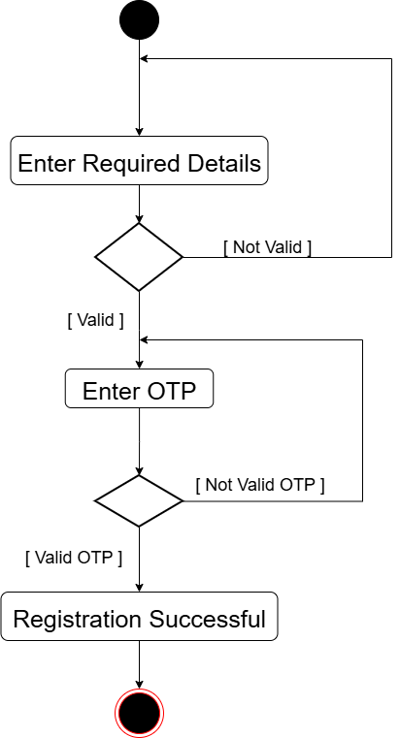

- Login Activity Diagram

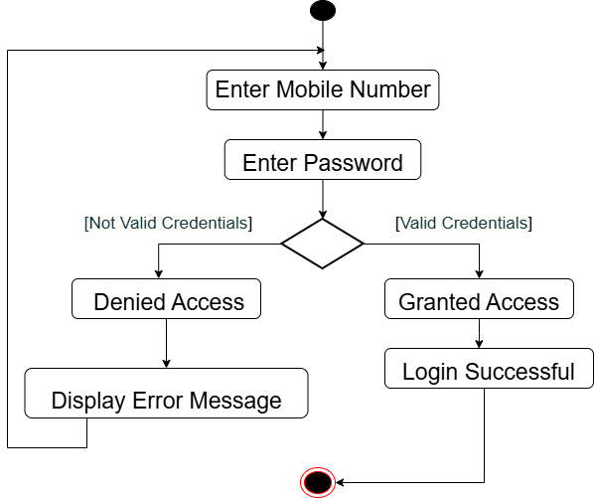

- Change Password Activity Diagram

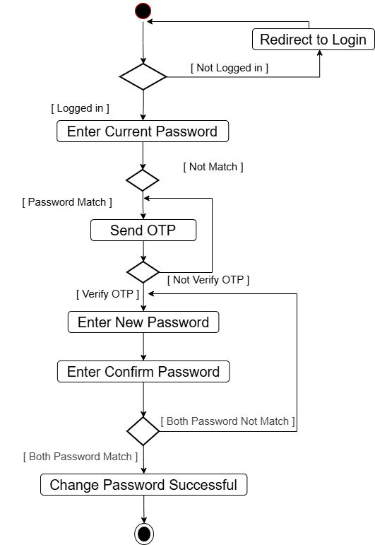

- Forgot Password Activity Diagram

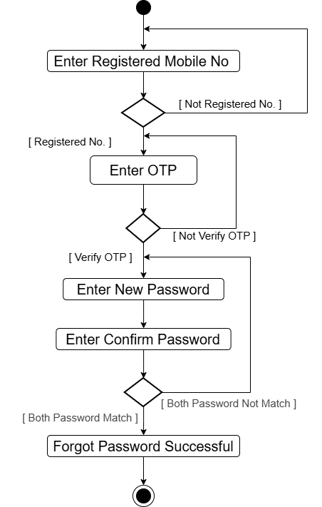

- Subscription Activity Diagram
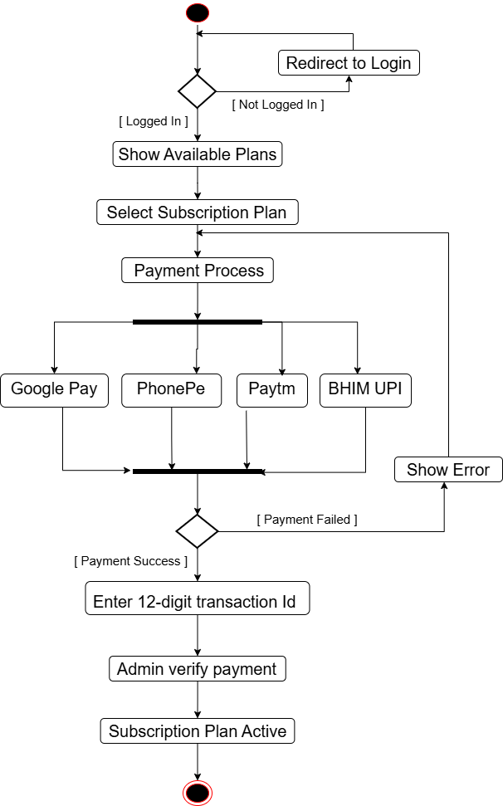

- Manage Equipment Activity Diagram
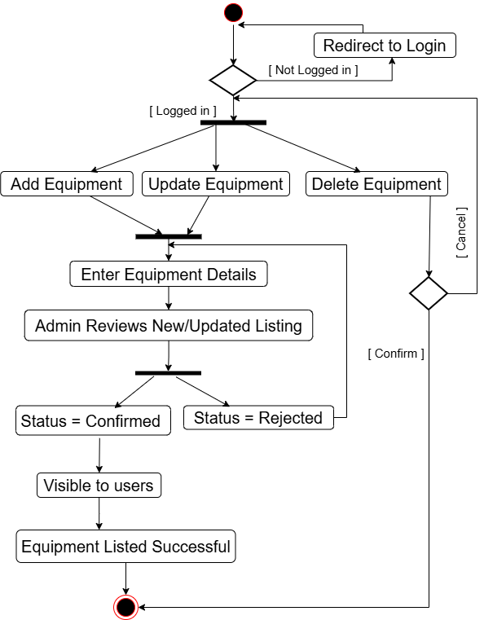

- Manage Product Activity Diagram
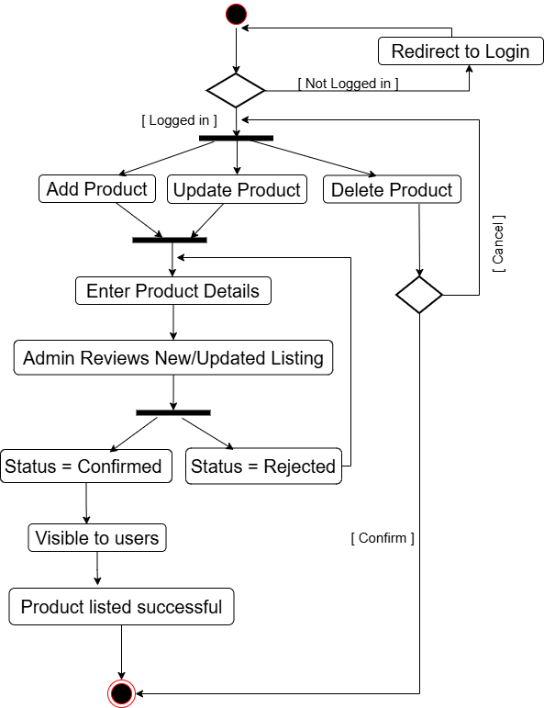

- Equipment Booking Activity Diagram
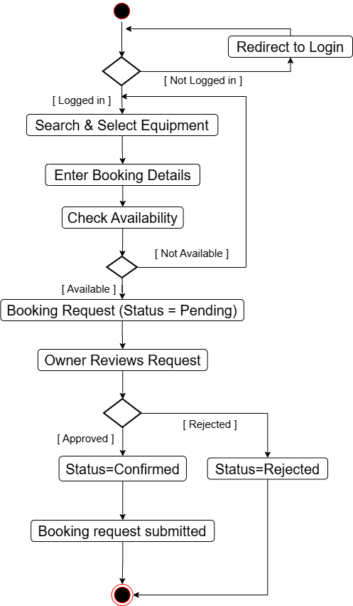

- Product Order Activity Diagram
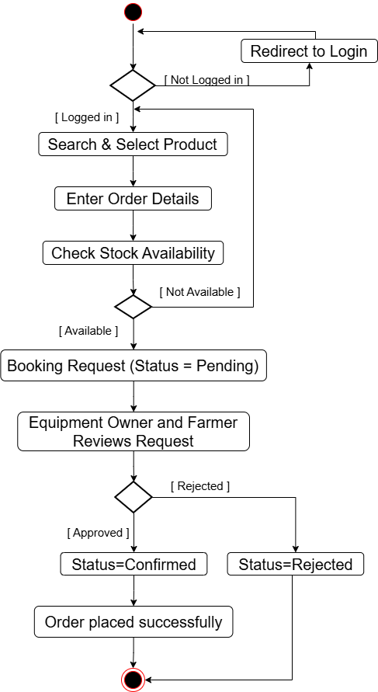

- Complaint Activity Diagram

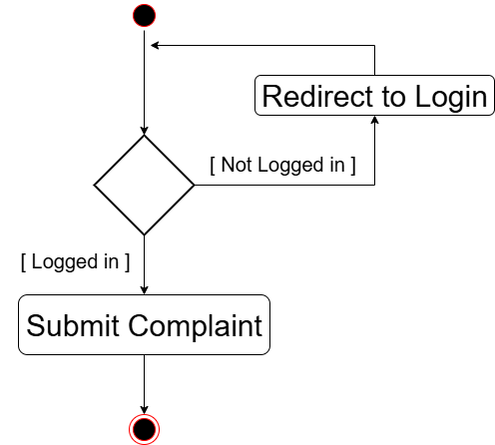

- Submit Review Activity Diagram
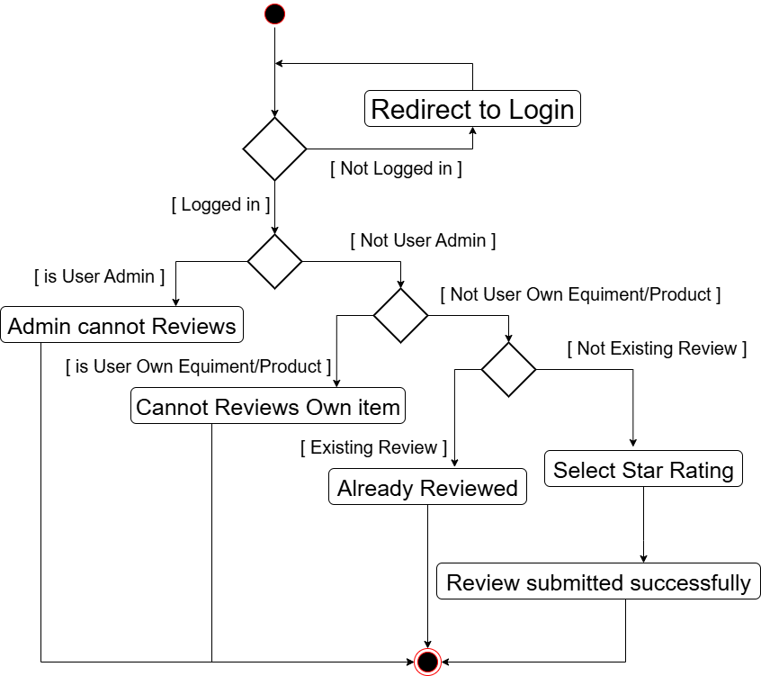

- Admin Generate Reports Activity Diagram
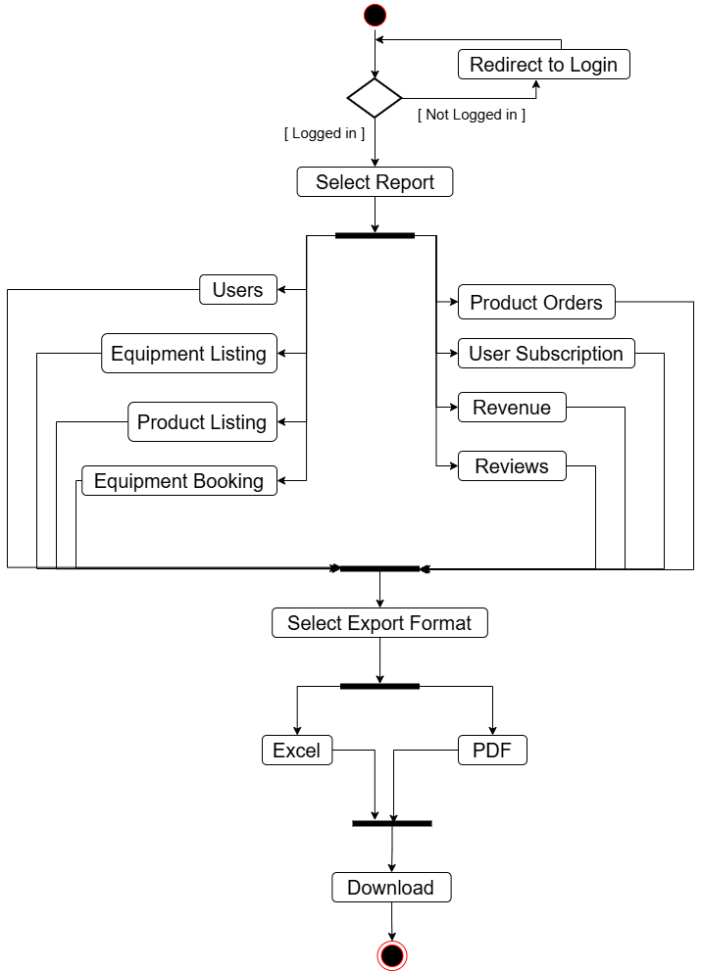

Chapter 5: System Design
5.1 System Design
- AgriRent uses a relational database structure to manage users, equipment, products, bookings, orders, payments, reviews, and complaints.
- Each entity represents a key component of the project, ensuring data integrity and smooth transactions between farmers, equipment owners, and administrators.
- Relationships between the tables are maintained via foreign keys, while constraints are applied to guarantee valid and consistent data throughout all functional modules.
5.1.1 Data Dictionary
- Users Table
Field Name | Datatype | Size | Constraint | Description
user_id | INT | 11 | PRIMARY KEY, AUTO_INCREMENT | Unique user identifier
Name | VARCHAR | 50 | NOT NULL | User's full name
Email | VARCHAR | 90 | UNIQUE | User's email address
Phone | CHAR | 10 | UNIQUE, NOT NULL | User's phone number
password | VARCHAR | 255 | NOT NULL | User password Max size is 20
User_type | CHAR | 1 | NOT NULL | Two type of Users :  O = Equipment owner  F = Farmer  A = Admin
status | CHAR | 1 | NOT NULL, DEFAULT 'A' | Account status:  A = Active  I = Inactive

- User Address Table
Field Name | Datatype | Size | Constraint | Description
address_id | INT | 11 | PRIMARY KEY, AUTO_INCREMENT | Unique address ID
user_id | INT | 11 | FOREIGN KEY, NOT NULL | References Users(user_id)
address | TEXT | - | NOT NULL | Complete street address
city | VARCHAR | 20 | NOT NULL | City Name
state | VARCHAR | 25 | NOT NULL | State Name
Pin_code | CHAR | 6 | NOT NULL | Postal PIN code

- Subscription Plans Table
Field Name | Datatype | Size | Constraint | Description
plan_id | INT | 11 | PRIMARY KEY, AUTO_INCREMENT | Unique plan identifier
Plan_name | VARCHAR | 50 | NOT NULL | Subscription plan name
Plan_type | CHAR | 1 | NOT NULL | Plan duration type:  M = Monthly  Y = Yearly
user_type | CHAR | 1 | NOT NULL, CHECK | user type:  F = Farmer  O = Equipment Owner
Price | DECIMAL | 10,2 | NOT NULL | Subscription price

- User Subscriptions Table

Field Name | Datatype | Size | Constraint | Description
subscription_id | INT | 11 | PRIMARY KEY, AUTO_INCREMENT | Unique subscription ID
user_id | INT | 11 | FOREIGN KEY, NOT NULL | References Users(user_id)
plan_id | INT | 11 | FOREIGN KEY, NOT NULL | References Subscription_Plans(plan_id)
start_date | DATE | - | NOT NULL | Subscription start date
end_date | DATE | - | NOT NULL | Subscription end date
Status | CHAR | 1 | DEFAULT 'P' | Subscription status:  P = Pending  A = Active  E = Expired  C = Cancelled

- Payments Table
Field Name | Datatype | Size | Constraint | Description
Payment_id | INT | 11 | PRIMARY KEY, AUTO_INCREMENT | Unique payment identifier
Subscription_id | INT | 11 | FOREIGN KEY, NOT NULL | References User_Subscriptions(subscription_id)
Amount | DECIMAL | 10,2 | NOT NULL | Payment amount
transaction_id | VARCHAR | 100 | UNIQUE | Payment transaction ID
UPI_transaction_id | VARCHAR | 12 | NOT NULL | 12-digit UPI transaction ID
Status | CHAR | 1 | NOT NULL, DEFAULT 'P' | Payment status:  P = pending  C = completed  F = failed
payment_date | DATETIME | - | DEFAULT CURRENT_TIMESTAMP | Payment date and time

- Equipment Categories Table
Field Name | Datatype | Size | Constraint | Description
category_id | INT | 11 | PRIMARY KEY, AUTO_INCREMENT | Unique category identifier
Name | VARCHAR | 50 | NOT NULL | Equipment category name
Description | TEXT | - | NULL | Category description

- Equipment Subcategories Table

Field Name | Datatype | Size | Constraint | Description
Subcategory_id | INT | 11 | PRIMARY KEY, AUTO_INCREMENT | Unique subcategory ID
Category_id | INT | 11 | FOREIGN KEY, NOT NULL | References Equipment_Categories(category_id)
Subcategory_name | VARCHAR | 70 | NOT NULL | Subcategory name
Description | TEXT | - | NULL | Subcategory description

- Equipment Table

Field Name | Datatype | Size | Constraint | Description
Equipment_id | INT | 11 | PRIMARY KEY, AUTO_INCREMENT | Unique equipment identifier
Owner_id | INT | 11 | FOREIGN KEY, NOT NULL | References Users(user_id)
Subcategories_id | INT | 11 | FOREIGN KEY, NOT NULL | References Equipment_Subcategories(Subcategory_id)
Title | VARCHAR | 50 | NOT NULL | Equipment title
Brand | VARCHAR | 50 | NOT NULL | Manufacturer brand name
Model | VARCHAR | 50 | NOT NULL | Equipment model number
Year | INT | 11 | NOT NULL | Manufacturing year
Description | TEXT | - | NOT NULL | Detailed equipment description
Hourly_rate | DECIMAL | 10,2 | NOT NULL | Hourly rental rate
Daily_rate | DECIMAL | 10,2 | NOT NULL | Daily rental rate
listed_date | DATETIME | - | DEFAULT CURRENT_TIMESTAMP | Equipment listing date
Approval_status | CHAR | 3 | DEFAULT 'PEN' | Equipment approval Status:  PEN = pending  CON= confirmed  REJ = Rejected

- Equipment and Product Images Table
Field Name | Datatype | Size | Constraint | Description
image_id | INT | 11 | PRIMARY KEY, AUTO_INCREMENT | Unique image identifier
image_type | CHAR | 1 | NOT NULL | Image type:  E = Equipment  P = Product
ID | INT | 11 | FOREIGN KEY, NOT NULL | References Product_id or Equipment_id
image_url | VARCHAR | 255 | NOT NULL | Image file storage path
upload_date | DATETIME | - | CURRENT_TIMESTAMP | Image upload date and time

- Equipment Bookings Table
Field Name | Datatype | Size | Constraint | Description
booking_id | INT | 11 | PRIMARY KEY, AUTO_INCREMENT | Unique booking identifier
equipment_id | INT | 11 | FOREIGN KEY, NOT NULL | References Equipment(Equipment_id)
customer_id | INT | 11 | FOREIGN KEY, NOT NULL | References Users(user_id)
start_date | DATE | - | NOT NULL | Rental start date
end_date | DATE | - | NOT NULL | Rental end date
Hours | INT | 11 | NOT NULL | Total rental hours
total_amount | DECIMAL | 10,2 | NOT NULL | Calculated total rental cost
status | CHAR | 3 | DEFAULT 'PEN' | Booking status:  PEN = pending  CON= confirmed  REJ = Rejected
time_slot | VARCHAR | 20 | NOT NULL | Selected time slot (e.g., 8AM - 8PM)

- Product Categories Table
Field Name | Datatype | Size | Constraint | Description
Category_id | INT | 11 | PRIMARY KEY, AUTO_INCREMENT | Unique product category ID
Category_name | VARCHAR | 50 | NOT NULL, UNIQUE | Product category name
Description | TEXT | - | NULL | Category description

- Product Subcategories Table
Field Name | Datatype | Size | Constraint | Description
Subcategory_id | INT | 11 | PRIMARY KEY, AUTO_INCREMENT | Unique subcategory ID
Category_id | INT | 11 | FOREIGN KEY, NOT NULL | References Product_Categories(Category_id)
Subcategory_name | VARCHAR | 70 | NOT NULL | Product subcategory name
Description | TEXT | - | NULL | Subcategory description

- Product Table
Field Name | Datatype | Size | Constraint | Description
product_id | INT | 11 | PRIMARY KEY, AUTO_INCREMENT | Unique product identifier
seller_id | INT | 11 | FOREIGN KEY, NOT NULL | References Users(user_id)
Subcategory_id | INT | 11 | FOREIGN KEY, NOT NULL | References Product_Subcategories  (Subcategory_id)
Name | VARCHAR | 50 | NOT NULL | Product name
Description | TEXT | - | NULL | Product detailed description
Price | DECIMAL | 10,2 | NOT NULL | Product price per unit
Quantity | DECIMAL | 10,2 | NOT NULL | Available quantity in stock
Unit | CHAR | 1 | NOT NULL | Measurement unit  K = Kilogram  L = liter
listed_date | DATE/TIME | - | DEFAULT CURRENT_DATE/TIME | Listing date
address_id | INT | 11 | FOREIGN KEY, NULL | References User_Addresses(address_id)
Approval_status | CHAR | 3 | DEFAULT “PEN” | Product approval Status:  PEN = pending  CON= confirmed  REJ = Rejected

- Product Orders Table
Field Name | Datatype | Size | Constraint | Description
Order_id | INT | 11 | PRIMARY KEY, AUTO_INCREMENT | Unique order identifier
Product_id | INT | 11 | FOREIGN KEY, NOT NULL | References Product(product_id)
buyer_id | INT | 11 | FOREIGN KEY, NOT NULL | References Users(user_id)
quantity | DECIMAL | 10,2 | NOT NULL | Ordered quantity
total_price | DECIMAL | 10,2 | NOT NULL | Calculated total price
delivery_address | INT | 11 | FOREIGN KEY, NOT NULL | References User_Addresses(address_id)
Status | CHAR | 3 | DEFAULT 'PEN' | Order status  PEN = pending  CON = Confirmed  CAN = cancelled
order_date | DATE/TIME | - | DEFAULT CURRENT_DATE/TIME | Order time
- Reviews Table
Field Name | Datatype | Size | Constraint | Description
Review_id | INT | 11 | PRIMARY KEY, AUTO_INCREMENT | Unique review ID
Reviewer_id | INT | 11 | FOREIGN KEY, NOT NULL | References Users(user_id)
Review_type | CHAR | 1 | NOT NULL | Review type: E = Equipment  P = Product
ID | INT | 11 | FOREIGN KEY, NOT NULL | Reference from Product ID or  Equipment ID
Rating | INT | 11 | NOT NULL, CHECK (1-5) | Rating value between 1 and 5 stars
comment | TEXT | - | NULL | Review comment text
created_date | DATETIME | - | DEFAULT CURRENT_TIMESTAMP | Review creation date

- Complaints Table
Field Name | Datatype | Size | Constraint | Description
Complaint_id | INT | 11 | PRIMARY KEY, AUTO_INCREMENT | Unique complaint identifier
User_id | INT | 11 | FOREIGN KEY, NOT NULL | References Users(user_id) - Complainant
Complaint_type | CHAR | 1 | NOT NULL | Complaint type:  E = Equipment  P = Product
ID | INT | 11 | FOREIGN KEY, NOT NULL | Reference from Product ID or  Equipment ID
Description | TEXT | - | NOT NULL | Complaint details
Status | CHAR | 1 | DEFAULT ‘Open’ | Complaint status:  O = Open  P = InProgress  R = Resolved

Chapter 6: System Implementation
6.1 Screenshots
(Include relevant screenshots that demonstrate the system's interfaces and functionalities.)

Chapter 7: Testing
7.1 Test cases
(List the test cases, describing inputs, expected outputs, and actual outputs.)
Test Case ID | Test Case | Inputs | Expected Output | Actual Output | Status
TC1 | Verify Login Functionality | Username: testuser  Password: Test@1234 | User is redirected to the dashboard | User is redirected to the dashboard | Pass

Chapter 8: Future Enhancement
(Describe potential future improvements, scalability options, or new features to be added.)
Chapter 9: Conclusion
(Summarize the key points of the project and highlight the achievements.)
Chapter 10: Bibliography
(List all sources, references, and materials used during the project.)

